Name :Sk.Kashifa

Registration no :192121135

Book bank management system

Class diagram :

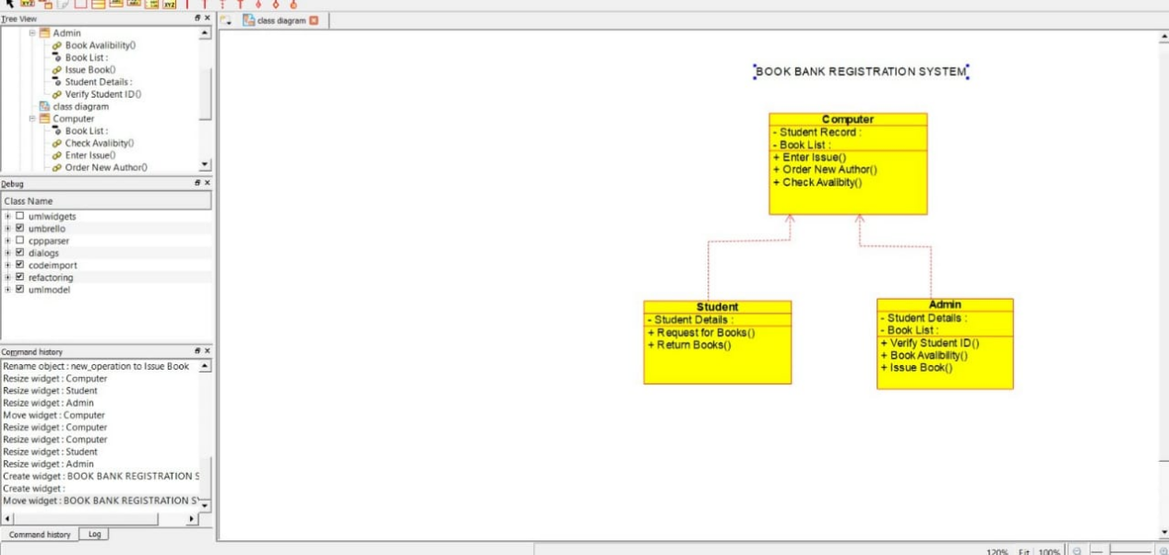

Sequence diagram :

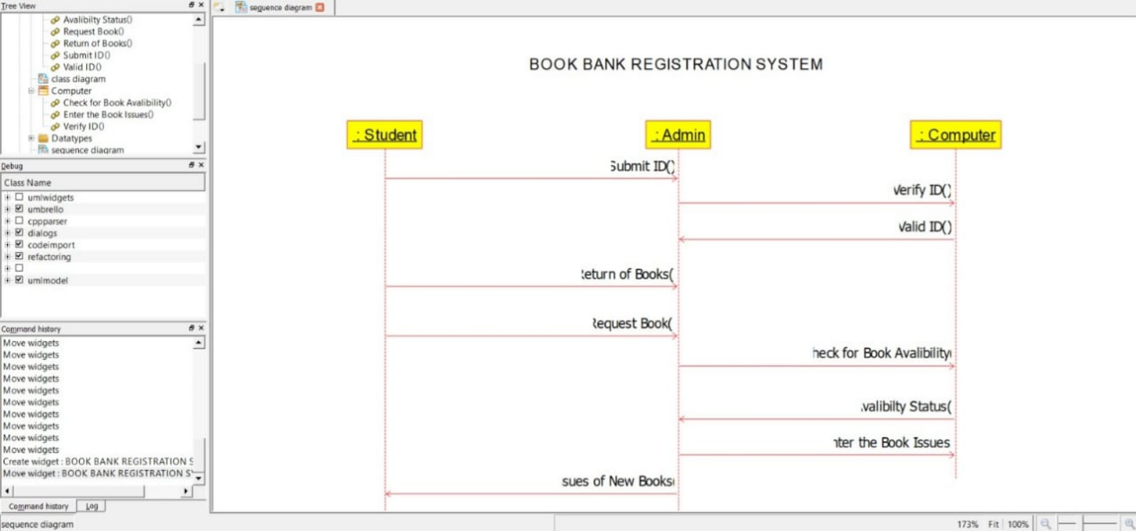

Deployment diagram :

